Key Takeaways from TILTing this assignment:
- As I first looked over the assignment I noticed there were a lot of things that could be confusing to novices in science. Though the explanation might be clear to someone with expertise, there were many things that required more scaffolding to help novices make the necessary connections.
- The purpose of the lab was not explicitly stated in the original assignment or at the very least it wasn't clear why it would be noteworthy to explore enzyme specificity.
- I hadn't considered before separating and distinguishing between practical physical skills (ie using Benedict's solution to test for the presence of aldehydes) from the knowledge (ie the connection between a positive result for glucose and enzyme specificity) that students would gain.
- This made me reflect on just how many individual skills and pieces of knowledge we are expecting students to simultaneously assimilate in one single lab assignment. It is no wonder it feels overwhelming.
- I sometimes am overwhelmed as well by the amount of information we are expected to teach in a given course and struggle with how to actually teach effectively when there is so much information to be covered. However, I think if we can better scaffold and communicate the purpose and criteria for success for assignments it can mitigate at least a portion of the information overload many students feel in these very fast paced introductory science classes.
- Even after I had done what made sense to me to improve the assignment I benefitted greatly from sharing with a non-content expert faculty colleague who found formatting suggestions as well as asking key questions that helped me further clarify and communicate with students through the assignment. I feel like this is now an essential step in solidfying any TILTed assignments I create in the future as you can benefit from other perspectives and the feedback of expert educators who may not have familiarity with your field so they can better catch when there are jumps in logic or inexplicit directions.
- I'm excited to try out this new improved assignment with students next time I teach this course to see if it improves student understanding and lab results. I intend to continue this work to improve all the labs for this course.

Enzyme Specificity of Sucrose and Lactose Hydrolysis (UNTILTED)

Carbohydrates, also known as sugars or saccharides, are one of the most important classes of compounds encountered in biochemistry. These compounds function as a source of energy for living organisms as well as providing structural materials for cells. Carbohydrates are complex molecules containing both alcohol and carbonyl functional groups.
Carbohydrates can exist as single sugar units called monosaccharides or as polymers called polysaccharides. An example of monosaccharide, glucose, is shown below.

Since glucose has both alcohol and carbonyl functionalities, it is able to form a ring; in the above case the glucose is in the pyranose form (6-membered ring). You will also notice that this is the α anomer; that is, the hydroxyl group on carbon 1 is down. When monosaccharides are in solution, an equilibrium exists between the open chain form and the two possible anomers, α and β.
When two monosaccharides react with each other they form a dissacharide. The reaction of one hydroxyl group on one sugar with a hydroxyl on another sugar forms a glycosidic linkage. In order to identify the disaccharide you need to know, which sugars are involved, the carbon atoms that contain the hydroxyl groups that join the two sugars, and the stereochemistry of the anomeric carbon. The structure below is for lactose.

Lactose, a disaccharide, is composed of a galactose and a glucose unit. In lactose, a glycosidic bond is formed with the hydroxyl group on carbon 1 of the β anomer of galactose. The hydroxyl group on glucose that participates in the glycosidic linkage is on carbon 4. Therefore, the glycosidic linkage in lactose is referred to as an β(14) linkage.
The enzyme that cleaves the β(14) linkage in lactose is called lactase. People who are lactose intolerant either lack or have reduced amounts of the enzyme lactase. When people with lactose intolerance ingest milk products they suffer from gas, bloating, stomach cramps, and possibly diarrhea. Lactase is commercially available for people into galactose and glucose, which does not cause the symptoms seen with lactose. Lactase is also available in tablet form and can be taken before ingesting milk products.
Sucrose is another dissacharide, only it contains the two monosaccharides glucose and fructose. Sucrose is known as table sugar. The fructose and glucose units are joined by a glycosidic linkage between the anomeric carbons on both sugars. Notice in the structure given for sucrose the stereochemistry on the anomeric carbon of glucose is α, whereas the stereochemistry on the anomeric carbon of fructose is β. This linkage is referred to as an α12β linkage, a linkage from carbon 1 of glucose to a β hydroxyl on carbon 2 for fructose.

D-Sucrose

As stated earlier, sugars are used by the body as a source of energy. To get energy from table sugar (sucrose), your digestive system must first break it into the monosaccharide units, glucose and fructose. In the case of sucrose the enzyme we use is sucrase, or also called invertase because the product of the reaction is called invert sugar.
Lactase and invertase are enzymes, which are proteins catalysts that accelerate the rate of a reaction. Enzymes are unique among catalysts in that they have great catalytic power as well as specificity. The degree of specificity varies among enzymes. In this experiment you will examine the specificity of the two enzymes lactase and invertase. Both enzymes perform hydrolysis reactions. They cleave the disaccharides into their component monosaccharides. You will determine if lactase is specific to lactose or will it also hydrolyze sucrose, or vice versa. You will use glucose test strips to look for the release of glucose upon the hydrolysis of the two disaccharides as the indicator for cleavage of the glycosidic linkage.

PROCEDURE:

- Add 0.3 g of sucrose to each of three test tubes and label the test tubes 1 to 3.
- To test tube 1, add 5 mL of distilled water (this will be a control). To test tube 2, add 5 mL of aq. invertase. To test tube 3, add 5 mL of aq. lactase. Shake the tubes to mix. Do not worry if all the sugar does not dissolve immediately; the sugar will dissolve upon heating.
- Add 0.3 g of lactose to each of three test tubes and label the tubes 4 to 6.
- To test tube 4, add 5 mL of distilled water (this will be a control). To test tube 5, add 5 mL of aq. invertase. To test tube 6, add 5 mL of aq. lactase. Shake the tubes to mix. Again, do not worry if not all of the sugar dissolves; the sugar will dissolve upon heating.
- Place the six test tubes in a warm water bath at 35-40°C for 40 minutes. Shake the tubes periodically to help the sugars to dissolve.
- While the test tubes are incubating, prepare an additional test tube with a small amount of glucose (pea size on tip of spatula) and 1 mL of water. You will use this to observe a positive test for glucose. Mix the glucose in the water and then dip the glucose test strip into the solution. The dipstick will come with a color chart that will indicate the approximate glucose concentration. Wait 30 - 60 seconds and note the color and concentration. Record the result in the data section.
- While you are waiting for your incubation prepare a water bath at 70 – 90°C in a 400 mL beaker.
- When the incubation of test tubes 1 – 6 is completed, allow the solutions to come to room temperature. Note that the dipstick test results will vary with temperature. Make sure all solutions have reached room temperature. Test each solution with a new dipstick. For each test tube, note the color and concentration in the data table.
- Now add 1 mL of Benedict’s solution to each of your seven test tubes and mix the solutions. Place all 7 test tubes in the water bath you prepared in step 7 for about 5 minutes. Formation of a red-orange precipitate indicates a positive test and confirms the presence of an aldehyde. Record your results in the data section.

CHEM 131 LAB 7 REPORT: Names_________________________

Turn in reports as a group Due :

Complete prelab in Canvas before attending lab.
Fill in the table with your results (4 pts)

 | Glucose Test Strip |  | Benedict’s Test
Test Tube (Sample) | Result (color) | Concentration | Result (color) | Pos / Neg
1 (sucrose control)
2 (sucrose + invertase)
3 (sucrose + lactase)
4 (lactose control)
5 (lactose + invertase)
6 (lactose + lactase)
7 (glucose control)

Questions (8 pts)

- For the dipstick test, what product indicates the hydrolysis of either lactose or sucrose?

- Considering the results of the glucose test strips, under what conditions did you see hydrolysis of sucrose?

- Considering the results of the glucose test strips, under what conditions did you see hydrolysis of lactose?

- What do the results of the glucose test strips tell you about the enzyme specificity?

- Does the Benedict’s test confirm the results from your glucose test strips?

- Why did you get a positive result on your Benedict’s test for one of the disaccharides?

Enzyme Specificity of Sucrose and Lactose Hydrolysis (TILTED)
CHEM&131

Purpose - In this experiment you will examine the specificity of the two enzymes lactase and invertase. You will determine if lactase is specific to lactose or will it also hydrolyze sucrose and vice versa.

Skills
- You will use glucose test strips to look for the release of glucose upon the hydrolysis of the two disaccharides as the indicator for cleavage of the glycosidic linkage.
- You will use Benedict’s solution to test for the presence of aldehyde groups, which will indicate whether aldoses are in their acyclic form. Note: This result may be different than what you find from the glucose test strips as the placement of the anomeric carbon relative to the glycosidic linkage can inhibit or allow for glucose to exist in it’s acyclic form while still part of a disaccharide unit.
Knowledge
- Know what lactase and invertase are and how they differ in their chemical function.
- Be able to define a monosaccharide, disaccharide & polysaccharide.
- Be able to define an anomeric carbon and explain why it’s presence in a glycosidic linkage for disaccharides prevents the aldehyde group from being “seen” until hydrolysis of the sugar by the appropriate enzyme
- Be able to explain why Lactose tests positive for aldehyde in all tests and Sucrose only when the appropriate enzyme is present.
Note: See background information in Appendix, recommended reading prior to pre-lab..

Minimum Criteria for Completion of Assignment
- Complete Pre Lab in Canvas before attending Lab
- Record detailed results : be specific about color (ie not just green, but what shade of green?), concentration (give a range based on the color), positive or negative (be sure to make notes to remember how you knew the results were positive or negative).
- Be careful to prevent cross contamination or your results may be inaccurate.
- Turn in your completed report with all required elements by the due date.

Tips for This Lab
Look for the light bulb for helpful tips on creating a successful experiment.
⚠ Look for the warning symbol for safety tips

Supplies
- labeled test tubes 1-7
- 400 mL beaker
- spatula
- dipsticks and color chart

Task
Prepare your test tubes 1-6 for incubation
- Label the test tubes 1- 6.
- Add 0.3 g of sucrose to test tubes 1-3.
- Test tube 1: add 5 mL of distilled water.
- Test tube 2: add 5 mL of aq. invertase.
- Test tube 3: add 5 mL of aq. lactase.
- Shake the tubes to mix

Student Results Recording Sheet (for your notes purposes only)
Test tube 1 is the control! Do not worry if all the sugar does not dissolve immediately; the sugar will dissolve upon heating
Prepare test solutions in each labelled test tube:
- Add 0.3 g of lactose to labeled test tubes 4-6
- Test tube 4: add 5 mL of distilled water (this will be a control).
- Test tube 5: add 5 mL of aq. invertase.
- Test tube 6: add 5 mL of aq. lactase.
- Shake the tubes to mix
- Place the six test tubes in a warm water bath at 35-40°C for 40 minutes.
- Shake the tubes periodically to help the sugars to dissolve.
While the test tubes are incubating (steps continued next page):
- Prepare a water bath at 70 – 90°C in a 400 mL beaker.
- Label test tube 7
- Add a pea size amount of glucose and 1 mL of water.
- Mix the glucose in the water and then dip the glucose test strip (dipstick) into the solution. Wait 30 - 60 seconds
- Use the dipstick color chart to indicate the approximate glucose concentration.
Glucose Test Results
Test Tube 7 Results
Record the result for your Lab report below. In the Lab Report Results table you should at a minimum include:
- Result (color, be descriptive)
- Concentration Range
- Positive or Negative Result
- Observations that support your determination of positive or negative result
Test Tube 1-6 Results (when the incubation of test tubes 1 – 6 is completed)
- allow the solutions to come to room temperature
- Test each solution with a new dipstick.
Dipstick test results will vary with temperature
Record the result of tubes 1-6 for your Lab report below. In the Lab Report Results table you should at a minimum include:
- Result (color, be descriptive)
- Concentration Range
- Positive or Negative Result
- Observations that support your determination of positive or negative result
Benedict’s Solution Test
Test tubes 1-7:
- Add 1 mL of Benedict’s solution to each of your 7 test tubes and mix.
- Place all 7 test tubes in the water bath for about 5 minutes.
Formation of a red-orange precipitate indicates a positive test and confirms the presence of an aldehyde. It may also appear greenish if there is a smaller amount of aldehyde present.
Record the result of tubes 1-6 for your Lab report below. In the Lab Report Results table you should at a minimum include:
- Result (color, be descriptive)
- Concentration Range
- Positive or Negative Result
Proceed to the Lab Report (next page) and complete all parts before turning in to the instructor by the due date.

Report Enzyme Specificity of Sucrose & Lactose Hydrolysis - CHEM 131
Names_______________________________________________________________________
______________________________________________________________________________
Turn in reports as a group
Fill in the table with your results (4 pts)
 | Glucose Test Strip |  | Benedict’s Test
Test Tube (Sample) | Result (color) | Concentration | Result (color) | Pos / Neg
1 (sucrose control)
2 (sucrose + invertase)
3 (sucrose + lactase)
4 (lactose control)
5 (lactose + invertase)
6 (lactose + lactase)
7 (glucose control)

Questions (8 pts)

- For the dipstick test, what product indicates the hydrolysis of either lactose or sucrose?

- Considering the results of the glucose test strips, under what conditions did you see hydrolysis of sucrose?

- Considering the results of the glucose test strips, under what conditions did you see hydrolysis of lactose?

- What do the results of the glucose test strips tell you about the enzyme specificity?

- Does the Benedict’s test confirm the results from your glucose test strips?

- Why did you get a positive result on your Benedict’s test for one of the disaccharides?

Appendix
Recommended reading for Pre-Lab
Carbohydrates, also known as sugars or saccharides, are one of the most important classes of compounds encountered in biochemistry. These compounds function as a source of energy for living organisms as well as providing structural materials for cells. Carbohydrates are complex molecules containing both alcohol and carbonyl functional groups.
Carbohydrates can exist as single sugar units called monosaccharides or as polymers called polysaccharides. An example of monosaccharide, glucose, is shown below.
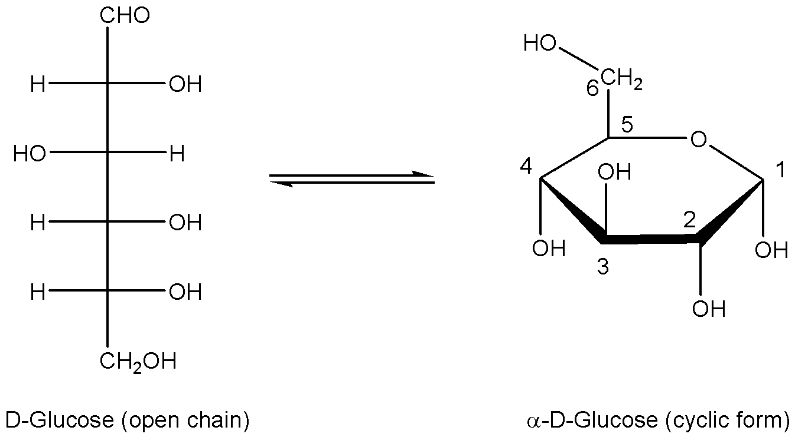

Since glucose has both alcohol and carbonyl functionalities, it is able to form a ring; in the above case the glucose is in the pyranose form (6-membered ring). You will also notice that this is the α anomer; that is, the hydroxyl group on carbon 1 is down. When monosaccharides are in solution, an equilibrium exists between the open chain form and the two possible anomers, α and β.
When two monosaccharides react with each other they form a dissacharide. The reaction of one hydroxyl group on one sugar with a hydroxyl on another sugar forms a glycosidic linkage. In order to identify the disaccharide you need to know, which sugars are involved, the carbon atoms that contain the hydroxyl groups that join the two sugars, and the stereochemistry of the anomeric carbon. The structure below is for lactose.

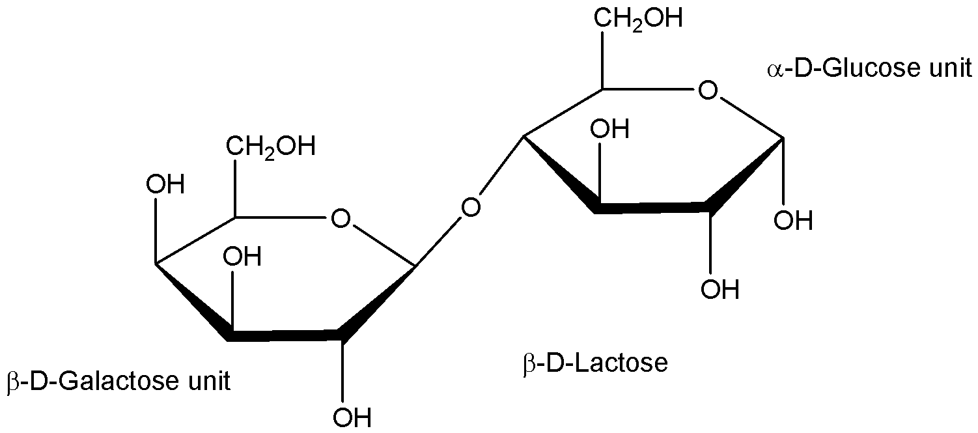

Lactose, a disaccharide, is composed of a galactose and a glucose unit. In lactose, a glycosidic bond is formed with the hydroxyl group on carbon 1 of the β anomer of galactose. The hydroxyl group on glucose that participates in the glycosidic linkage is on carbon 4. Therefore, the glycosidic linkage in lactose is referred to as an β(1🡪4) linkage.
The enzyme that cleaves the β(1🡪4) linkage in lactose is called lactase. People who are lactose intolerant either lack or have reduced amounts of the enzyme lactase. When people with lactose intolerance ingest milk products they suffer from gas, bloating, stomach cramps, and possibly diarrhea. Lactase is commercially available for people into galactose and glucose, which does not cause the symptoms seen with lactose. Lactase is also available in tablet form and can be taken before ingesting milk products.
Sucrose is another dissacharide, only it contains the two monosaccharides glucose and fructose. Sucrose is known as table sugar. The fructose and glucose units are joined by a glycosidic linkage between the anomeric carbons on both sugars. Notice in the structure given for sucrose the stereochemistry on the anomeric carbon of glucose is α, whereas the stereochemistry on the anomeric carbon of fructose is β. This linkage is referred to as an α1🡪2β linkage, a linkage from carbon 1 of glucose to a β hydroxyl on carbon 2 for fructose.
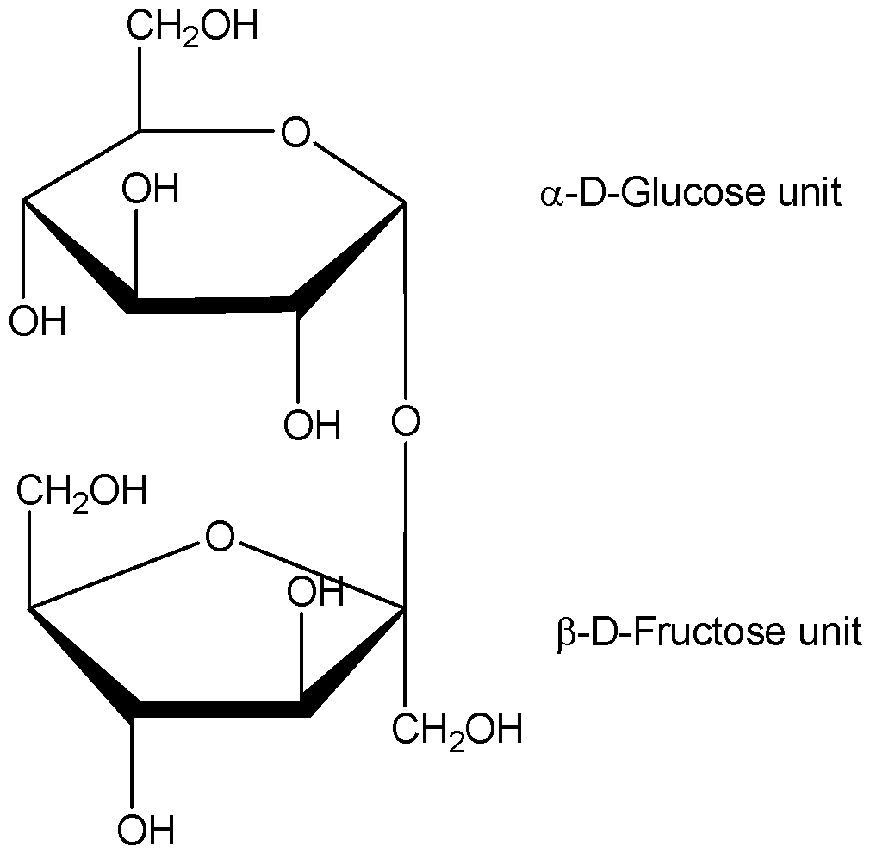

D-Sucrose

As stated earlier, sugars are used by the body as a source of energy. To get energy from table sugar (sucrose), your digestive system must first break it into the monosaccharide units, glucose and fructose. In the case of sucrose the enzyme we use is sucrase, or also called invertase because the product of the reaction is called invert sugar.
Lactase and invertase are enzymes, which are proteins catalysts that accelerate the rate of a reaction. Enzymes are unique among catalysts in that they have great catalytic power as well as specificity. The degree of specificity varies among enzymes.In this experiment you will examine the specificity of the two enzymes lactase and invertase. You will determine if lactase is specific to lactose or will it also hydrolyze sucrose, or vice versa. You will use glucose test strips to look for the release of glucose upon the hydrolysis of the two disaccharides as the indicator for cleavage of the glycosidic linkage. Both enzymes perform hydrolysis reactions. They cleave the disaccharides into their component monosaccharides.

