TILT Project SOC&101 Introduction to Sociology Assignment Sample
TILTED ASSIGNMENT
Doing Sociology: Analyzing Cultural Change over Time
DUE DATE: xxxx, 2020
PURPOSE:
The purpose of this assignment is to provide students with an opportunity to practice and refine sociologically-informed archival research skills. You will demonstrate your sociological imagination by thinking about how the data that you find tells us about social change over time. Thinking about the relationship between data, the conclusions we draw from them, and how we could reject our conclusions is a skill that you can use throughout the rest of their life.
KNOWLEDGE:
You will practice the following skills that are essential to your development as a sociology student, including:
- Locating and acquiring information about cultural change by visiting archives data sources.
- Analyzing observational data for content.
- Speculating about relationships between social variables as well as change in social variables over time.
- Reflecting on how speculations created by the student could be tested.
TASK:
Find archival data, use it to create three hypotheses about social change over time, and consider how those hypotheses could be tested and falsified.
HOW TO COMPLETE THE TASK IN EIGHT EASY STEPS:
1. Think about a product that has been advertised for at least sixty years.
Visit www.vintageadbrowser.com to look for advertisements.
2. Choose one product.
- Pick a product that has been advertised for at least sixty years.
- Choose one ad for this product from six different decades (e.g. 1910s, 1930s, 1950s, 1970s, 1990s, 2010s).
- Copy and paste the advertisement into a word document.
- Copy and paste the URL into a word document.
- Make sure that you don’t choose an off-limits topic: United Airlines, Chanel #5, cigarettes, Coca-Cola.
3. [Observations] Describe the sociological information in the advertisements in rich detail.
Write down information from the advertisement that tells you information about social and/or cultural variables at the time the ad was created. Information to consider might include the following and more:
- Who is in the ad?
- Describe race/ethnicity, gender, and class data for the people in the ad.
- What relationships do you see in the ad?
- What values, beliefs, and norms do you see promoted in the ad?
- How does the presentation of the ad tell you about the social and cultural values of the time?
4. [Speculations] Use your data to create three hypotheses
Based on the data from step 3, create three guesses about how social and/or cultural variables might be changing over time and explain a bit about why the hypothesis makes sense. Make sure that each guess is phrased in the language of the course by making a claim about how two variables relate to each other. For example:
My first hypothesis is that economic prosperity decreased sharply beginning in the 1980s as there is suddenly no reference to luxuries, which signals a decline in the ability to pay for services.

- In this example, “time” is the independent variable
- “economic prosperity” is the dependent variable and
- “decreased” describes the relationship between time and economic prosperity.
5. [Falsification] Reflect on falsifiability and how you could test your hypotheses
After creating three hypotheses in Step 4, consider what it means to say that they are falsifiable as well as how you could test them. Begin by defining what a falsifiable hypothesis is. Continue by describing data that would lead you to reject each of your three hypotheses. Finish by noting the type of study that you would use to evaluate each hypothesis. For example:
If a hypothesis is falsifiable, it means that _____________________. My first hypothesis could be proven wrong if there was no economic recession in the 1980s. The best test to evaluate this hypothesis would be an archival study.
6. Write a brief summary
In a short paragraph, review your experience by summarizing what you have done, what you know, and what next steps would be. Do you see a theme in the data? If so, point it out.
7. Cut unnecessary data in order to make your paper two pages or less.
Use your hypotheses to tell you which data in your description from Step 3 is necessary.
- If your hypotheses are about goats, sheep, and cows, you can cut all of the data that relates to apples, strawberries and mangoes.
- A good rule is to keep your data description to one page or less.
8. Stitch your work together, and check formatting.
Now that you are almost finished, make sure that your document includes all of the necessary pieces.
- Name, Class, Date in the header.
- Data description, hypotheses, section on falsifiability and conclusion
- Ads so that Geoff can see them. Paste these into the end of your document
- URLs so Geoff can look up your ad if he needs to do so. Paste these into the end of your document

CRITERIA:
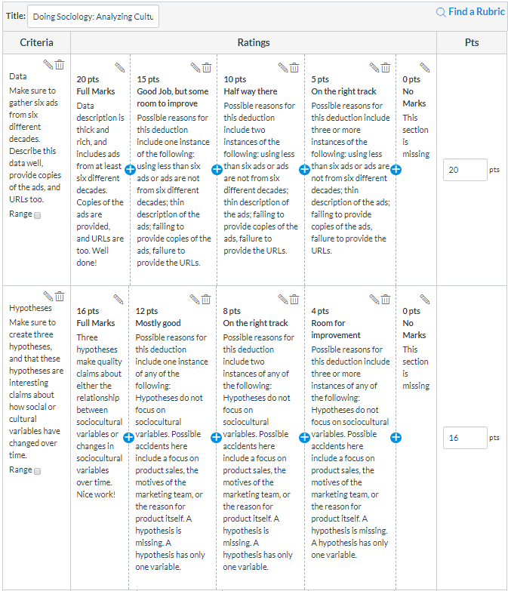
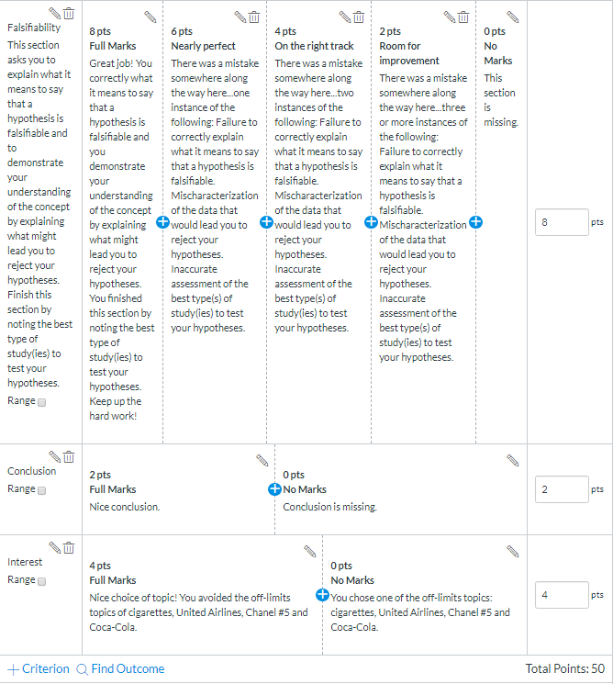

Sample paper on following page

Student Name
SOC&101
Month Day, Year

Short Writing Assignment 2: Culture through Time
All ads are United airlines ads, from the 1940s to the 1990s. The first ad from the 1940s depicts a woman in nice clothes, the ad’s language appears to target business women specifically, and emphasizes the comfort and cleanliness of the aircraft, the language plays on traditional women’s stereotypes. The second ad from the 1950s is similar except that it targets executive men even stating, “FOR MEN ONLY”. The features described deal with traditional men’s interests such as drinking and smoking. The first two ads appear to target wealthy individuals looking for luxurious transit and support gender roles. The 1960s ad describes the reliability and advanced technology of the company while also portraying a stewardess in formal clothing holding a steak, a stereotypical role. The ad also contains the phrase “the Extra Care airline”, demonstrating the importance of hospitality. The fourth ad from the 1970s continues to support the upper-class image of flying as well as traditional gender roles with a large space filled with well dressed older people being served by a younger and formally dressed stewardess. All ads up to this point have focused exclusively on domestic travel which may indicate the insular and nationalist attitudes held in the cold war period. A significant departure is present in the 1980s ad, with no people being depicted and no references to luxury. The ad shows several coins all labelled with an Asian country, and the slogan “Complete your set”. A possible symptom of economic hardship within the country as there is less emphasis on service as well as an indication of increasingly multicultural views within the U.S. The final ad depicts a man from Singapore with a fruit cart, another potential sign of warming relations with Asia.
My first hypothesis is that economic prosperity decreased sharply beginning in the 1980s as there is suddenly no reference to luxuries, which signals a decline in the ability to pay for services. My second hypothesis is that American travel to Asia increased after the 1970s as both ads following that decade deal with travel to Asia, compared with the domestic nature of ad’s from the 1940s-1970s. My final hypothesis is that gender equality has been increasing since the 1950s. The first two ads seem to sharply stereotype women and men whiles ads after that period tend not to reference gender.
A hypothesis is falsifiable if the researcher is able to gather the data that they need in order to evaluate the hypothesis. My hypotheses could be proven wrong if there was no economic recession in the 1980s, if percentage of American travel to Asia did not increase after the 1970s and if gender inequality measured by pay gap grew since the 1950s. Archival research would be the only way to study these hypotheses as the changes they examine have already occurred. Examining statistics from the respective time periods could either support or disprove my hypotheses.
These ads establish a general timeline of change, the breakdown of traditional values and an increase in progressiveness such as gender equality and multiculturalism. They also signal a shift in why we fly; these ads by United initially appealed to a businesslike and wealthy demographic, going out of their way to demonstrate the luxury they are able to provide in the ads from the 1940s-1970s. After that there is very little emphasis on comfort or wealth which may demonstrate a shift to a more equal, utilitarian culture.

Work Cited
1940s: http://file.vintageadbrowser.com/l-kszd1qnwrgm2db.jpg, Retrieval Date: 10/19/18
1950s: http://file.vintageadbrowser.com/l-eq3gc4yz1bu5j0.jpg, Retrieval Date: 10/19/18
1960s: http://file.vintageadbrowser.com/d5urlmotjg168x.jpg, Retrieval Date: 10/19/18
1970s: http://file.vintageadbrowser.com/w0z4jp78w4jwxo.jpg, Retrieval Date: 10/19/18
1980s: http://file.vintageadbrowser.com/o68sv68hv3j3ox.jpg, Retrieval Date: 10/19/18
1990s: http://file.vintageadbrowser.com/g2p4jzi2qyob2i.jpg, Retrieval Date: 10/19/18

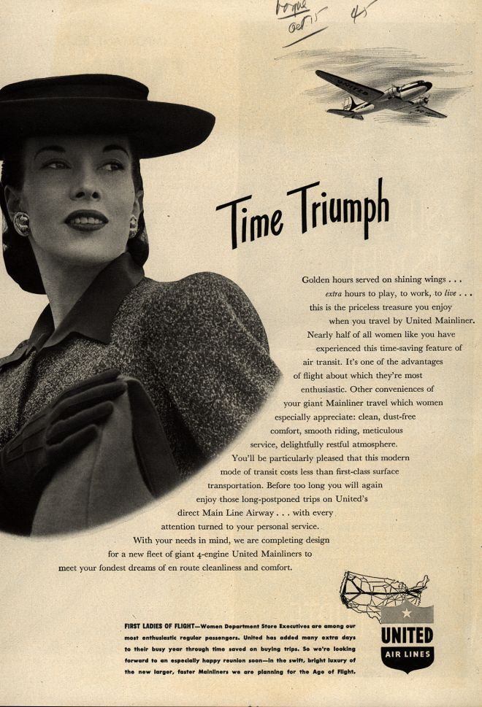

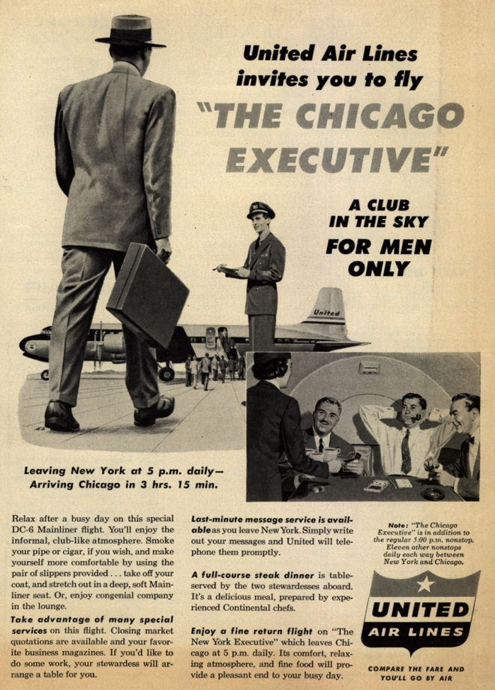

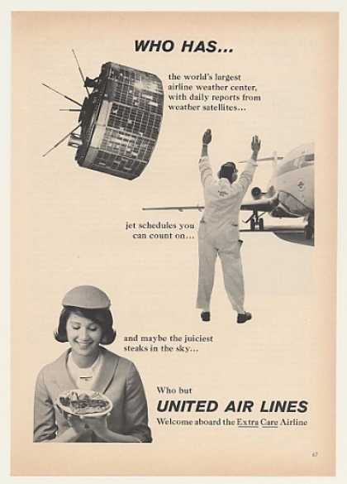

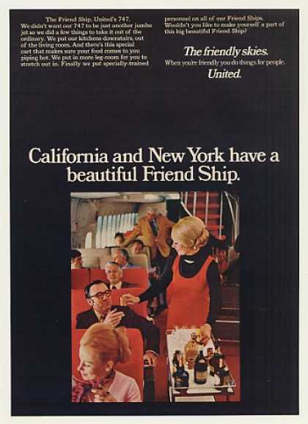

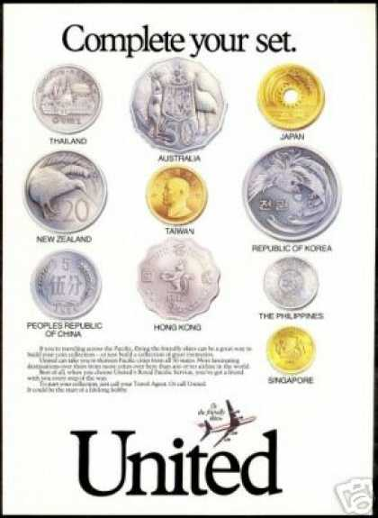

ASSIGNMENT BEFORE TILT
Culture Through Time
Summary: For this assignment, you will experience parts of the archival research process by scouring the archives for clues about cultural change. You will observe and describe clues about cultural change in historical ads, speculate about what cultural changes might have been occurring, and discuss ideas about falsification.
This paper may not be more than 2 pages, must adhere to the guidelines for written work in the syllabus, and does not require any extra outside reading. Papers that are not double-spaced will not be accepted.
Observations: This hunt begins by finding advertisements in print from magazines, newspapers, or other media. You will need a total of six ads from six different decades. Try to make your research as specific as possible by choosing one product and manufacturer.
- Attach copies of the ads to the back of your paper. You should not include your ads within the text of your paper.
- If you use printed resources, provide brief bibliographic data like source, year, and author if available.
- If you use electronic resources, include the URL and retrieval date of the resource.
- These ads and references will not count toward your two page maximum.
- Failure to do the above will result in my treatment of the advertisement as missing
Describe your archival data. Make sure that your observations are rich enough to support your responses to speculations below. You may not be able to include all of the information that you generate. That said, as a beginning part of the observation process, you may want to detail the following:
- Notice the people in the ad. Based on what they are wearing or what they are carrying, what might they be doing, and what norms or values are expressed? If people are not in the ad, explain who you think the ad is intended for. What norms do they abide by? Which symbols have meaning?
- Notice the ages, genders, class status, and race/ethnicity of people in the ad. Who seems to be in ads, and does this change at different points in time?
- Notice the design elements of the ad. What do the taglines tell you about the intended audience for the ad? What types of norms and values do these taglines promote or uphold? How is language used? How is space used?
Speculations: Using your archival data, generate three hypotheses about how social variables (e.g. the elements of culture, income, race, age, family/relationship characteristics, occupation, and education, etc.) have changed over time. Hypotheses are of the highest quality when they speculate about how variables are related and are clearly drawn from observations. Hypotheses that are unrelated to observations and hypotheses about company sales are of low quality. Hint: Focusing on the changes in culture or society that the ads reflect is way more interesting than thinking about product sales, or even the product itself.
Ideas about Falsification: Explain what it means to say that your hypotheses are falsifiable, what data that would falsify your speculations would look like, and what type of study you could use to best test your speculations.
Conclusion: In the final paragraph, use the information you provided to sum up the paper by developing a theme. What are commonalities among the ads? Are there trends of change, or forces of continuity?
Grading Criteria
Observations (20 points): The paper thoroughly and succinctly describes the advertisements in terms of their substance. Ads are attached.
  - 2 points each for description of ads from different decades
  - 2 points each for quality of description
  - If ads are not attached as images and/or bibliographic information is not provided, no credit for this section.
Speculations (16 points): The paper insightfully uses archival observations to generate three falsifiable hypotheses
  - 8 points for three hypotheses—must relate two variables together! Hint: Many people find that "time" works wonderfully as an independent variable.
  - 8 points based on quality of hypotheses
Ideas about Falsification (8 points):
  - 4 points for statements that explain why your hypotheses are falsifiable.
  - 2 points for statements explaining which type of study would be best to test your hypotheses.
  - 2 points for description of the findings that would reject your hypotheses.
Conclusion (2 points): The paper finishes by arguing how culture may have changed based on the information presented by the researcher.
Interest (4 points): The paper does not focus on clichéd topics, but takes risks in describing social phenomena that promote interest. This means that you will lose points if you focus on Budweiser, Coca-Cola, Cigarettes, or Chanel #5.

Key Takeaways from TILTing this assignment:
- As an instructor, I am vulnerable to the possibility that I believe that I am communicating more clearly than I actually am. The TILT framework asks for a different way of communicating information about assignments to students, and I am grateful for the chance to try a new approach.
- Jamie Wilson was instrumental in providing the support and flexibility that allowed me to complete this exercise.
- Thinking about the step-by-step skills that students need in order to complete this semmingly-simple project made me consider what I was assuming about the skills that students bring with them to the class. Breaking down the tasks into smaller steps could lead to improved outcomes.
- I discovered that the order of operations to complete the task was a bit counter-intuitive and not clearly articulated in the original prompt.
- I am concerned about whether students will learn to expect the same degree of specificity in future courses, and how that expectation could impact both learning and job performance. In other words, will students step back and see the process that TILTed assignments lead them through so that they can replicate that process on their own in their futures?
- I wonder if this change will improve student outcomes for this task. I look forward to evaluting the results.
- I am curious to learn more about how the more detailed rubrics help students to improve over the course of their college careers. Will they read the rubrics to understand how to improve?

